SIGNING INTO A COMPUTER ON THE SLCC NETWORK

- When you are at the computer, select Ctrl+Alt+Delete at the home screen.

- Select “OK” on the next screen.
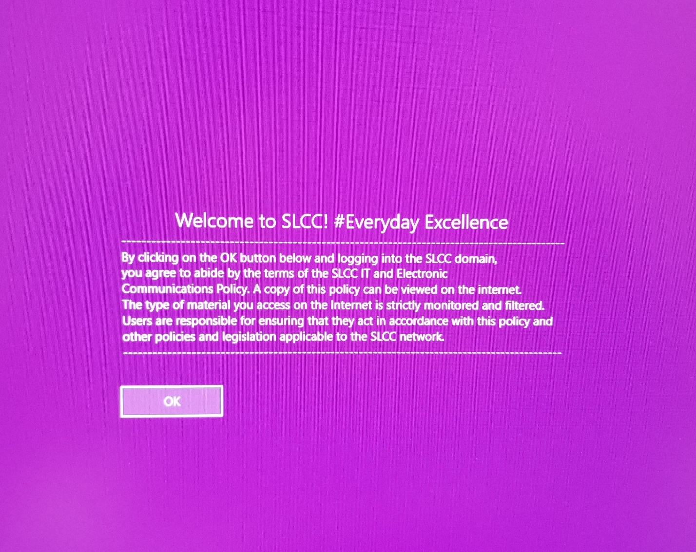

- Using the default password given to you by HR, please login using the below format.

Username: firstname.lastname (ex. new.user)
Password: *use default password*
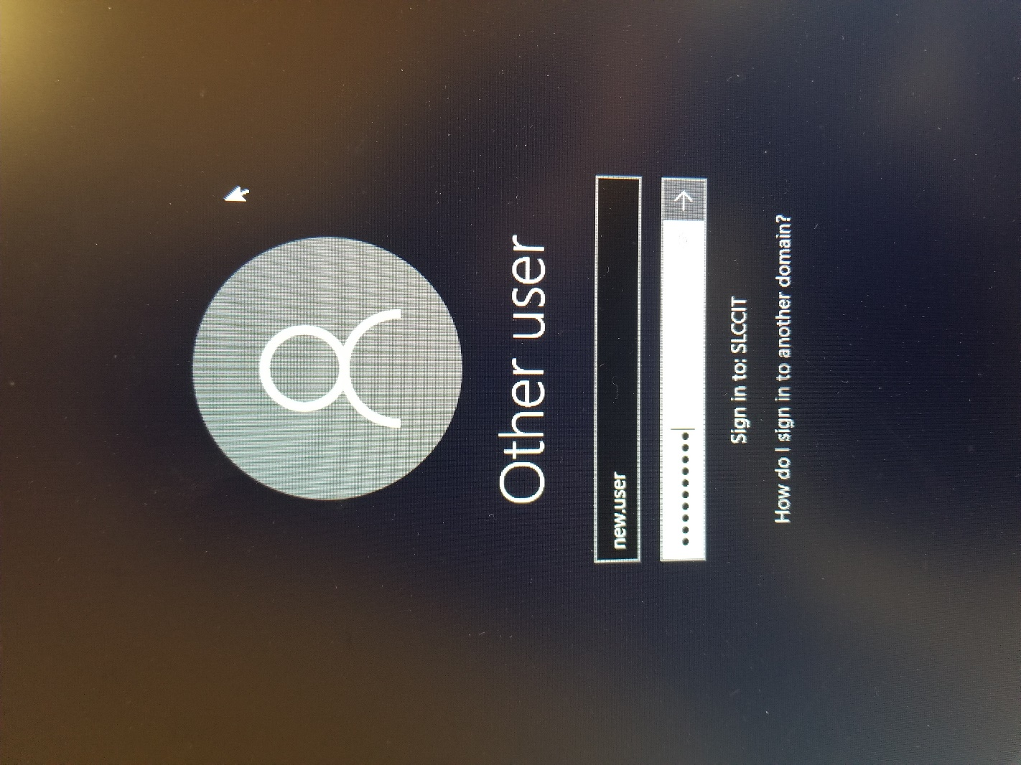

- Once you sign in, you will be prompted to change your password.
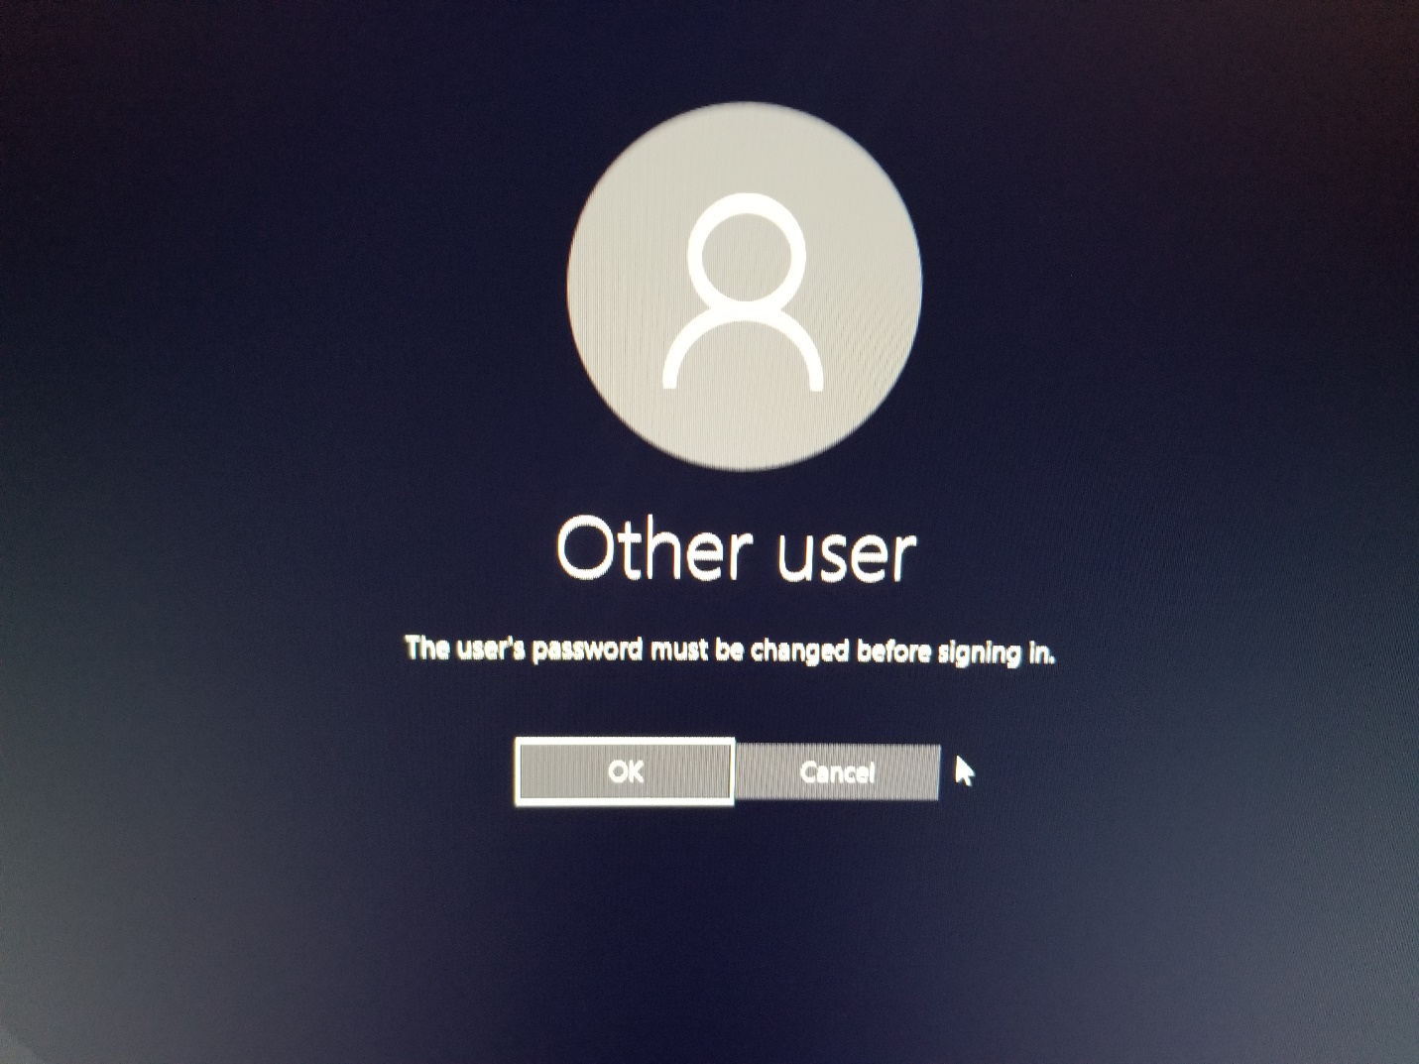

- Please create a custom password that will be used going forward to sign into the computer and to access your email. Your new password must meet the below requirements.

- One capital letter
- One lowercase letter
- One number
- One special character
- Must be at least 8 characters long
- Cannot include your first or last name
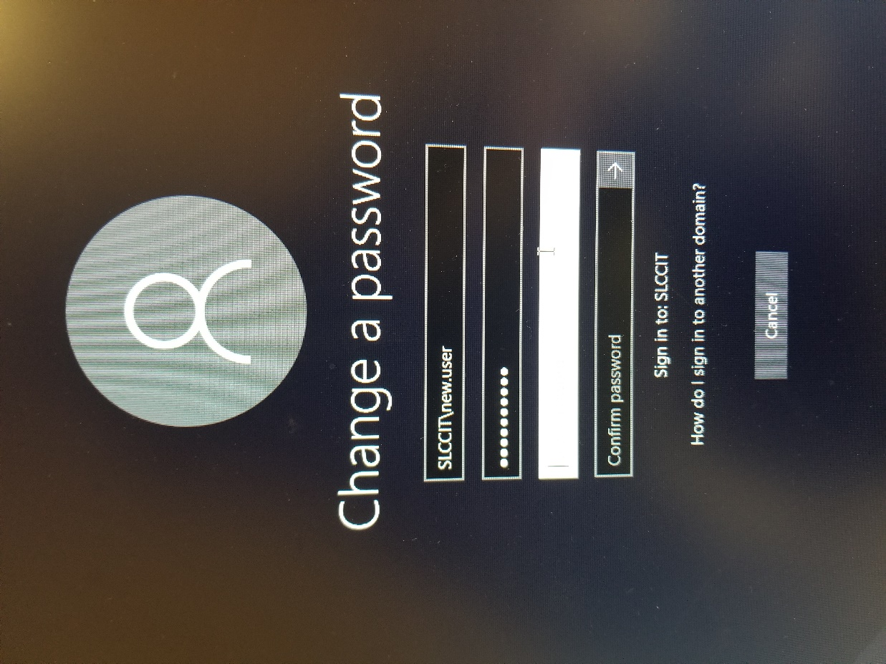

- Once your password has been changed, select “OK”.
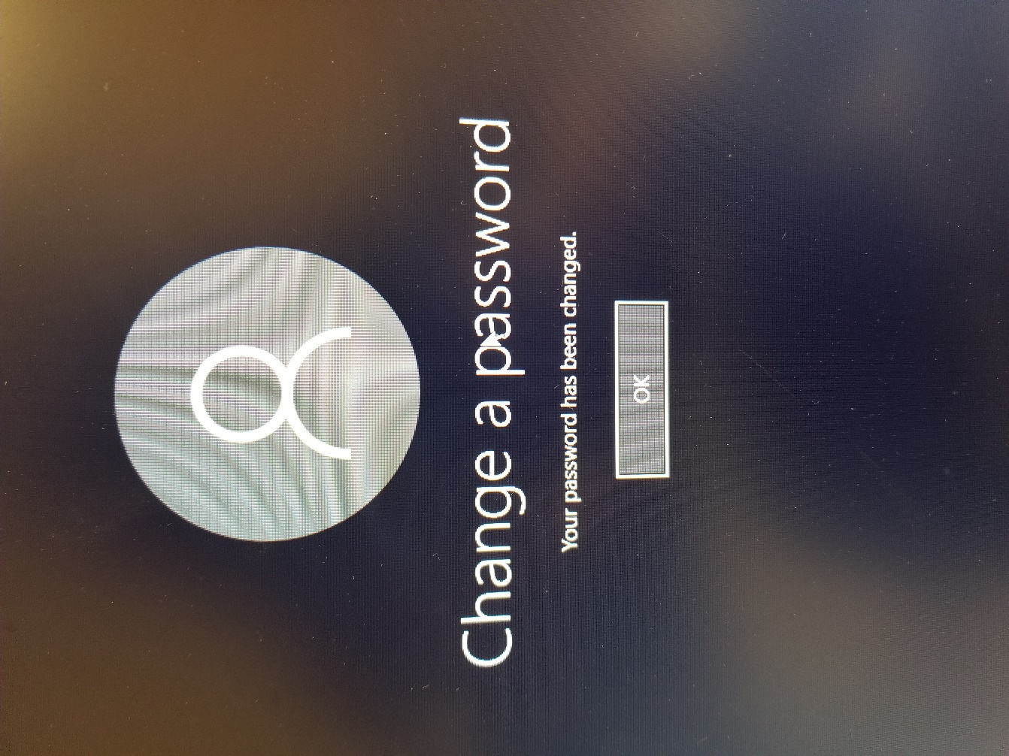

- You will then be signed into the computer.
