INSTALLING MICROSOFT OFFICE 365 SUITE FROM WEB

- Login to your SLCC email account through the web. You can also visit www.office.com and sign in with your SLCC email address. After you are signed in, select the menu in the upper left corner (9 square tiles) and select Office 365 to the right.
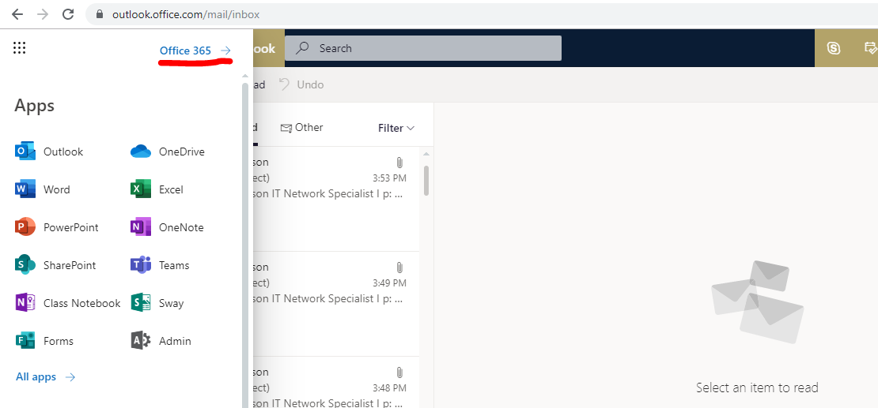

- Once you are on the apps page, select “Install Office” on the right-hand side.

- Select “Office 365 apps”
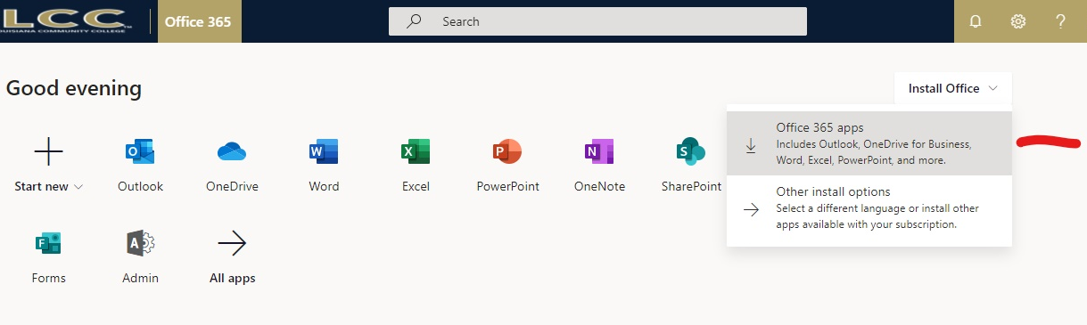

- Office 365 will download to your computer.
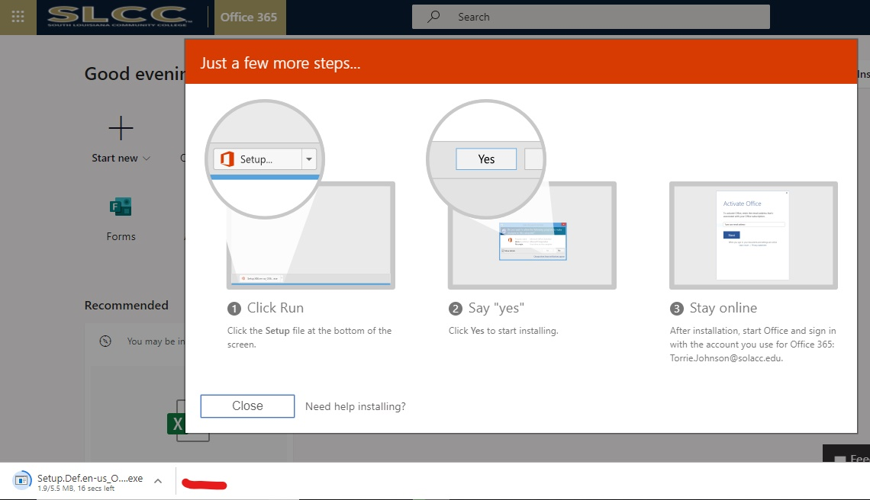

- After download is complete, go to your Downloads folder and run the recently installed program. Follow the prompts given by the installer. Once complete, the Microsoft Office Suite will be installed.

***If further assistance is needed, please contact the IT Helpdesk.
Email: itsupport@solacc.edu
Phone: 337-521-8940

