ACCESSING SLCC EMAIL ACCOUNT FROM THE WEB

- From an internet browser, visit solacc.edu. From the top menu, you will select “Webmail”.

- On the next screen, enter your SLCC email address.
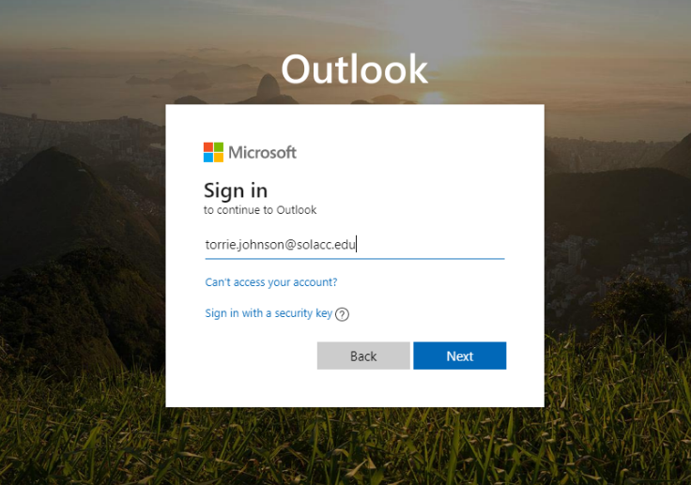

- Enter your SLCC password that was created when you signed into the computer.

- You will then be brought to your inbox.
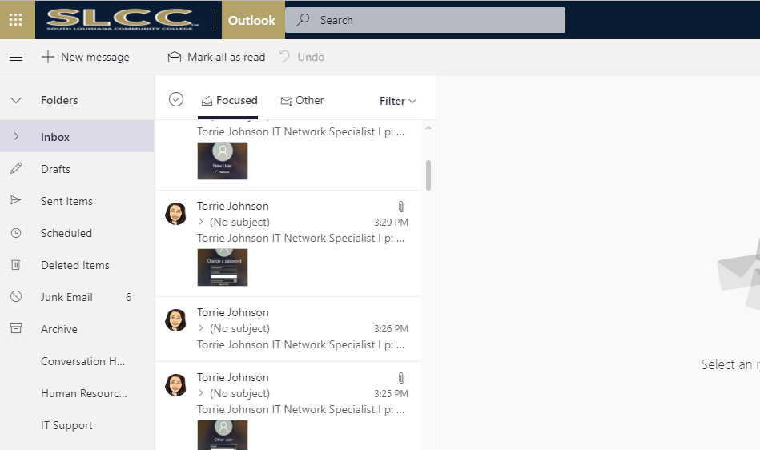

***If further assistance is needed, please contact the IT Helpdesk.
Email: itsupport@solacc.edu
Phone: 337-521-8940

