ACCESSING EMAIL FROM OUTLOOK ON COMPUTER

- From the Start menu, type “Outlook”. You should see the application show up. Press the “Enter” key.
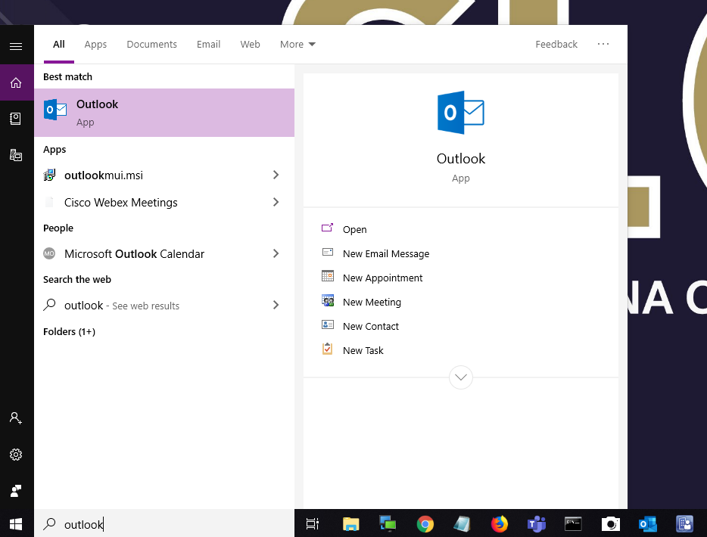

- Your name should already be populated in the next box. Select “Connect”. When prompted for password, enter the password that you created when logging into the computer.
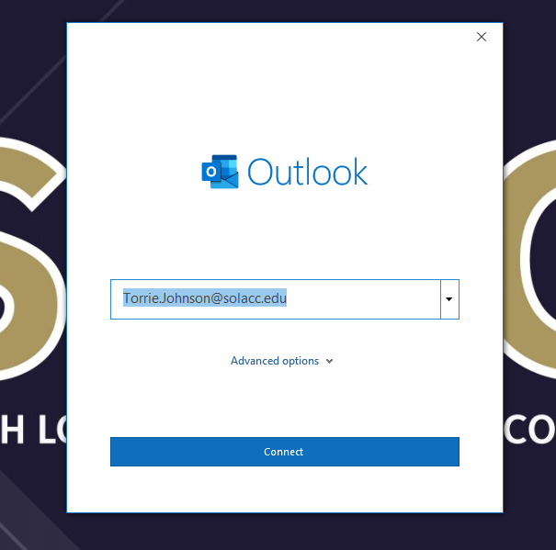

- Once setup is complete, you will be brought to the below screen. Un-check the box at the bottom for “Set up Outlook Mobile on my phone, too” and select “Done”.
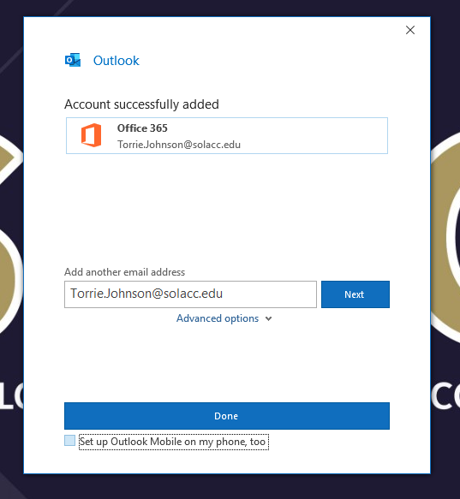

- You will then be brought to your inbox. You will see emails populate on the left-hand side.

***You may be prompted to sign in again to activate the Office suite. You will sign in using your SLCC email address and password.

***If further assistance is needed, please contact the IT Helpdesk.
Email: itsupport@solacc.edu
Phone: 337-521-8940

