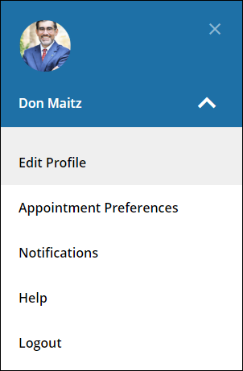
Your Profile
Click your name to open your Starfish Profile. Select Edit Profile to update your contact information, photo, and information students see about you. Select Appointment Preferences to set up your Appt. defaults, Locations, and Calendar Managers. Select Notifications to set up Appt. email reminders, and tracking item email options.

Office Hours
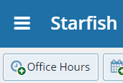
From the Home page select Office Hours to create single or recurring set of office hours.
Tips on adding Office Hours:
Title: Displays on your calendar to distinguish sets of office hours.
Where?: Options are added via Edit Profile > Appointment Preferences tab.
Office Hour Type: If you are using a Kiosk, use Scheduled and Walk-ins.
Appointment Types: Use to limit an office hour block to one meeting type i.e. Advising.
Edit/Cancel a series of office hours from the Agenda view. Hover over this icon to edit the frequency, time of day, locations, office hour types, minimum and maximum duration of appointments, appointment types, instructions, or start/end date of the series.
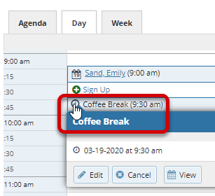
Edit/Cancel individual occurrences from the Day view of the calendar. Hover over this icon to display a pop up card from which you can take additional actions.
Important Note:
Once an office hour block is saved, you will not be able to edit weekdays on which it occurs or type of frequency (i.e. weekly).

Progress Surveys
Select the Outstanding Progress Survey link on the Starfish Home page.
Check the boxes presented for each desired item/ student combination.
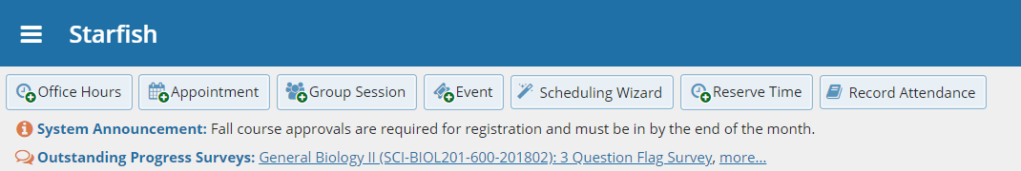
Click the comments icon () to add notes.
Click the information icon ()to verify whether the student can view the flag.

Tip: Do not click Submit until you are finished with your survey. You will be unable to edit a submitted survey. You can, however, raise a flag on a student at any time during a term.

